**MAJOR DRIVERS OF INTERANNUAL CLIMATE VARIABILITY IN AFRICA IN 2017**

ENSO

There are large scale changes in the atmosphere or ocean that influence conditions over many regions in the world on seasonal to interannual timescales. The links that connect these large changes with regional or localized hazards are referred to as teleconnections. At the global level El Nino Southern Oscillation (ENSO) is one of the best known major driver of interannual variability. In Africa, strong El Nino is usually connected to droughts over southern Africa ( e.g 2015/16 ) and above average rainfall and/or floods during the last quarter over Eastern Africa.

ENSO neutral conditions characterized the first three quarters of 2017. A weak to moderate La Nina dominated the last quarter in 2017 and the first quarter of 2018.

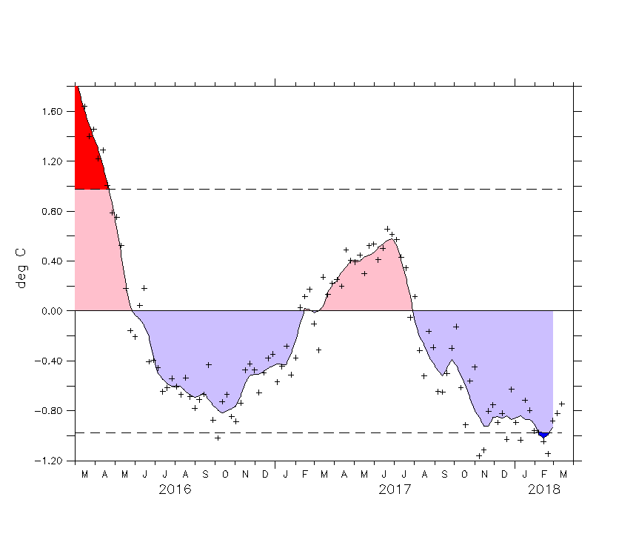

Fig: ENSO

TROPICAL NORTH ATLATIC

The Tropical North Atlantic (TNA) variability is related monsoon rainfall over the Sahel. Positive TNA is usually favorable for active monsoon rainfall over the Sahel and particularly its westernmost part during summer. In 2017 ( see figxx) this positive phase dominated the region with possible impact on the observed active monsoon rainfall ( sees fig precip for JAS 2017).

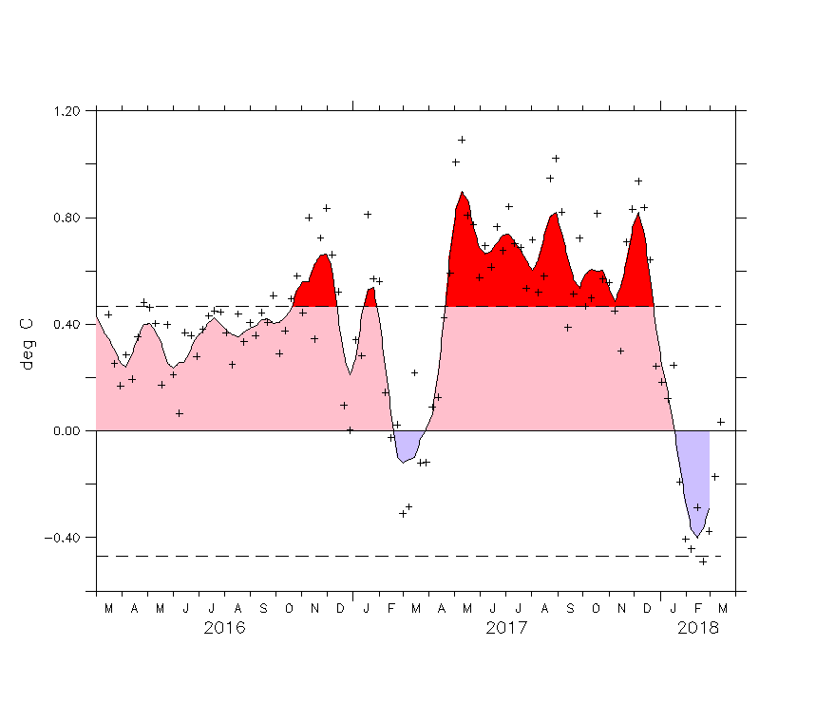

Figure: Tropical North Atlantic SST. Much of 2017 showed warm phase of TNA.

TROPICAL SOUTH ATLANTIC

The Tropical south Atlantic SST variability affects the Sahel, the Gulf Of Guinea and the tropical eastern Atlantic coasts of Africa. This pattern was near average during much of 2017 with weak positive anomalies during the first three quarters and weak negative during the last quarter. Seasonal precipitation patterns during the year indicate near to above average precipation along the the southern atlantic coastal areas of Africa during the first three quarters with a reverse condition during the last quarter characterized by near to below average TSA.

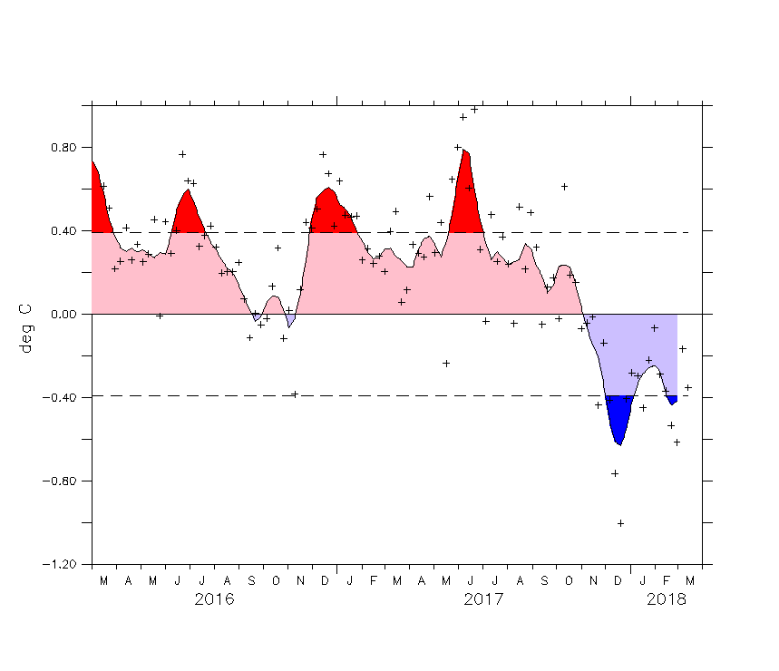

Fig TSA

The Tropical Atlantic SST index represent an important mode of SST variability in the Atlantic Ocean. Positive index is favorable for active African monsoon. Fgi xx indicates that this positive phase dominated the monsonn season and precip fig xx confirm and active monsson in 2017.

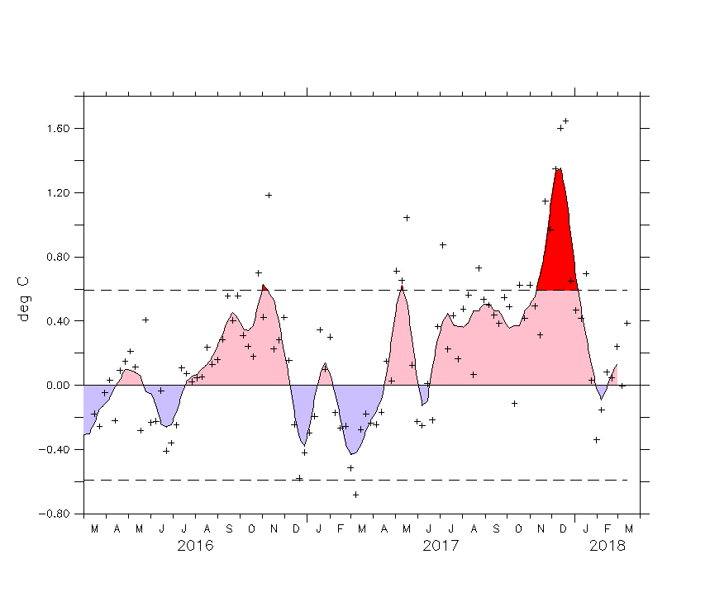

Fig: index: ) Atlantic Ocean basin showing TASI region (b) Observed TASI SST time series from the Ocean Observations Panel for Climate

INDIAN OCEAN DIPOLE

The Indian Ocean Dipole describes the variability between the western and Eastern part of this ocean. Its positive phase is favorable for more precipitation during the last quarter of year in Eastern Africa. Reverse is the case during negative phase. Fig xx indicates that in 2017, this index was mostly near average during the last quarter of the year. Some negative precipitation anomalies for OND 2017 was reported over parts of coastal eastern Africa.

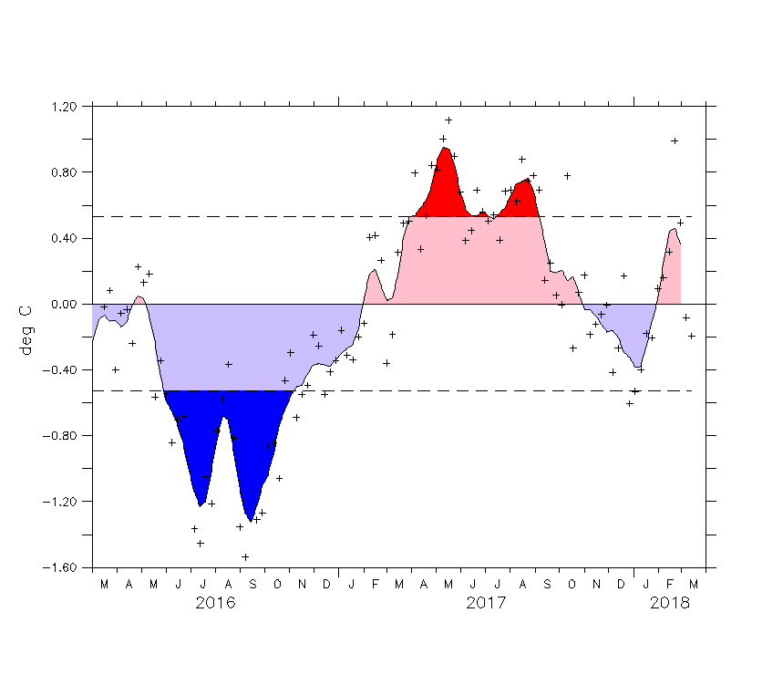

Fig: Indian Ocean Dipole mode